The Template File for Microsoft Word for

AutoCarto/UCGIS 2018 Conference and Symposium Submissions

Scott M. Freundschuh

ABSTRACT: The purpose of this template is to make all of the submissions fit a common format. This is done by following the instructions included in this template. You should use this template for position papers (1000 words), for paper abstracts (both 500 word and 1500 words), and for lightening talks and poster abstracts (500 words). With your attention to detail, we will have a great conference with extraordinary papers, and make a significant impact on the fields of Cartography and Geographic Information Science.

KEYWORDS: Quote five or so key words that would be useful in a web search for your paper. For this example template: KEYWORDS: template, AutoCarto 2018 conference, UCGIS Symposium, proceedings

Introduction (example of heading1 style)

This is the content of the introduction. The text is Times New Roman, 12 point, single spacing. There is a 12pt space between paragraphs. It is indented for each new paragraph, after a major header.

This is the second paragraph. I have deliberately left a blank line to separate it from the previous paragraph. Please keep to this format throughout the document.

As far as references go, DO NOT USE footnotes. For references, use the (Author, Date) style. For example, Smith (1990) indicated that cartography can be fun. That cartography is indeed fun, is clearly evident from the literature (Smith, 1990; Smith and Jones, 1991; Smith et al., 1992). To quote Smith, “cartography is great fun” (Smith, 1997, p. 187). Use the “et al.” form for more that two authors.

Method

Dealing with tables and figures (example of heading2 style)

Special attention should be devoted to making sure that figures and tables fit within the bounds of this page (i.e. 6 inches width, centered). Each figure should stand alone, with a caption and a reference in the text (Figure 1).

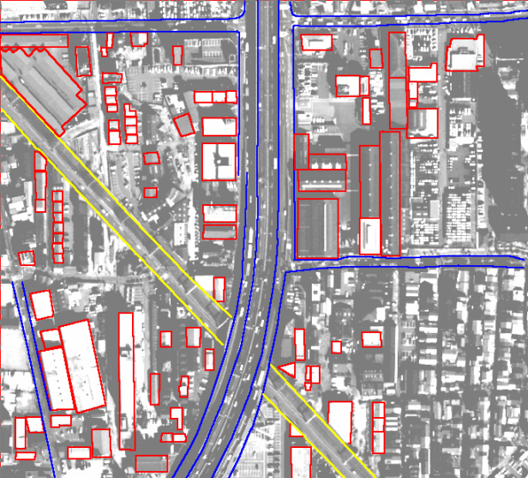

Figure 1: A gratuitous graphic. Source: http://www.hgiis.com/images/pic_app_cartography.jpg. Use this caption style for figures and tables.

When you need to insert an equation, just go ahead and use the Word equation editor, for example:
$$A=πr^{2}$$

There is no need to number equations, unless it is important to refer to them. Tables can be treated the same as figures, and be embedded into the Word file. They should be referred to in the text, and have their own number sequence, independent of figures. They also need captions. Avoid having figures and tables roll over or be split between pages. You can usually move them around until they appear on their own page. If not, you can force a new page using the Insert Tab and Break menu choice. Use the standard table tools in Word, or import the table from Excel or equivalent (Table 1).

Table 1: A meaningless table, added to show the basics of formatting.
Distance from Point A (mm) | Distance from Point B (mm) | Value assigned | Purpose
1.2 | 1.3 | 1000 kP | Instruction
3.1 | 2.1 | 1020 kP | Distraction

Results

Many papers follow an IMRAD format, that is Introduction, Methods, Results, Analysis and Discussion (Davis, 2005). Of course there are many different paper formats. Follow the one that communicates your findings best. Use passive voice for preference, avoid grey literature, and use the third person.

Conclusions

If we all follow this easy to use template, hours of valuable time will be saved in preparing the conference proceeding.

References

These are formatted using the AutoCarto-References style:

Davis, M. (2005) Scientific Papers and Presentations, 2ed. Oxford: Elsevier Academic Press.

Smith, A. (1999) Maps: A Laugh a Minute. Hungarian Journal of Cartographic Logic, 11, 6, pp. 145-180.

Smith, A. and Jones, B. (1991) More Cartographic Hilarity. Cartography and Geographic Information Science. 22, 1, pp. 123-145.

Smith, A. Jones, B. and Smythers, C. (1992) Two Years of Cartographic Humor. http://www.funnymaps.com Last visited 5/19/2008.

End your submission with your name(s) and affiliation(s), e.g.,

Scott M. Freundschuh, Professor, Department of Geography and Environmental Studies, University of New Mexico, Albuquerque, NM 87131

